**Memo**

To: Professor Pisano

From: SeokYoung Choi, Nick Gutierrez, Eunhye Kwon, and Yumin Wei

Team: 24

Date: 4/26/2023

Subject: Customer Installation Report

1. **Detail of Customer Installation**

Client: Brandon Miller from Phillips

Location: Phillips Research at 222 Jacobs St., Cambridge, MA 02141

Date of Visit: April 20, 2023

Members Present: SeokYoung Choi, Nick Gutierrez, Eunhye Kwon, Yumin Wei

Customers Present: Brandon Miller and a team of his co-workers

**2.0 Requirements**

| Requirement | Progress |
| --- | --- |
| Objective: Create a specialized video game controller for those with hand arthritis to participate in the gaming community more actively | Final Product: E-Remote is an inclusive video game controller for those with hand arthritis. |
| Function: User-programmable buttons | Final Product: This was completed. |
| Function: Wireless Bluetooth connectivity with sync time < 30 secs to a PC, PlayStation, or other systems of choice | Final Product: This was completed for a PC. |
| Function: Intuitive user layout with the basic understanding gained in 5 minutes with provided manual | Final Product: This was completed. |
| Functions: Reusable batteries to begin → Rechargeable battery source with 3.3V and 24-hour battery life | Final Product: Rechargeable Lithium Ion Polymer Battery (3.7V, 500mAh) and 24-hour runtime |
| Constraint: Input lag < 200ms | Final Product: Input lag is 100ms. |
| Constraint: Can fit in a common 22 × 14 × 9 inches backpack | Final Product: 10.7 x 6 x 2.5 inches |
| Constraint: Cost per Unit < $99.99 | Final Product: The cost of production is $70.50. |
| Deliverable: A user manual explaining how to configure/operate the controller to the user’s preference and how to connect the controller to their system | Final Product: This was completed. |
| Deliverable: Demonstration of the overall feasibility of the controller by completing a level from 3 different genres of games (Levels to be chosen together by the design team and client) | Final Product/Exceeded: The E-Remote is compatible with all PC games. |

**3.0 Overall Assessment**

We visited the Philips Research building in Cambridge on April 20 to showcase our final product to our client, Brandon Miller, and his co-workers at Phillips. In a private room, we presented our poster to people in person and online. After the presentation, we answered questions. Some of the questions asked were:

* What was the hardest part about the project? Each problem we came across, we were able to fix, but the one thing we had problems with was figuring out the battery. We decided to use the HUZZAH32 which has a charging port and battery included, but this limited our battery.
* What would be a solution to the battery? Getting a smaller ESP chip and buying our own battery rather than being limited to the HUZZAH board. But this would also require buying a charging port and a charging board.
* What games can you play with the controller? We started with just arcade, puzzle, racing, and shooting, but now with the D-pad, we can play any type of PC game.
* Can you play Mario Kart? Unfortunately, no because we are only compatible with PC, not Nintendo due to proprietary reasons.

After answering questions, we allowed people to choose a game and play with the controller. We continued this demonstration for around an hour, switching between 5 people and 4 games. We also brought the standard Xbox controller, therefore people we able to compete against each other: the E-Remote vs the Xbox controller. From this demo, we received some feedback:

* The left joystick kept popping out, need to fix the joint.
* Input lag was noticeable to one person.

Overall, we believe everything went well. Once we got back to the lab, SeokYoung created new joints and the left joystick is now fixed. Nick also tested the input lag of the E-Remote, and it seems like the problem was because of the projection during the meeting rather than the Bluetooth connectivity.

**4.0 Customer Acceptance Email**

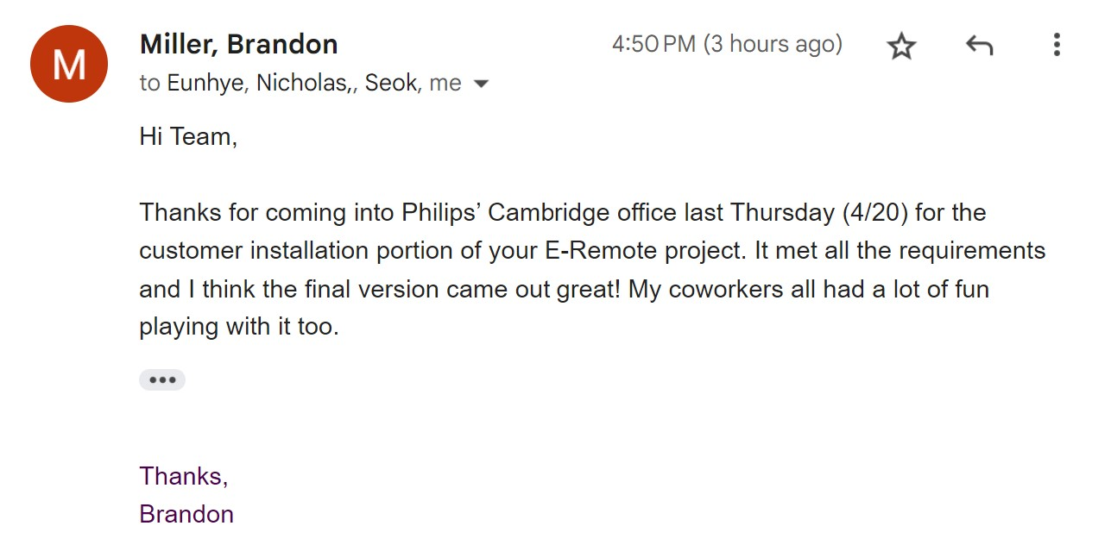

Figure 1: Customer Acceptance Email from Brandon Miller

Figure 2: Team Photo with Brandon Miller at the Phillips Office